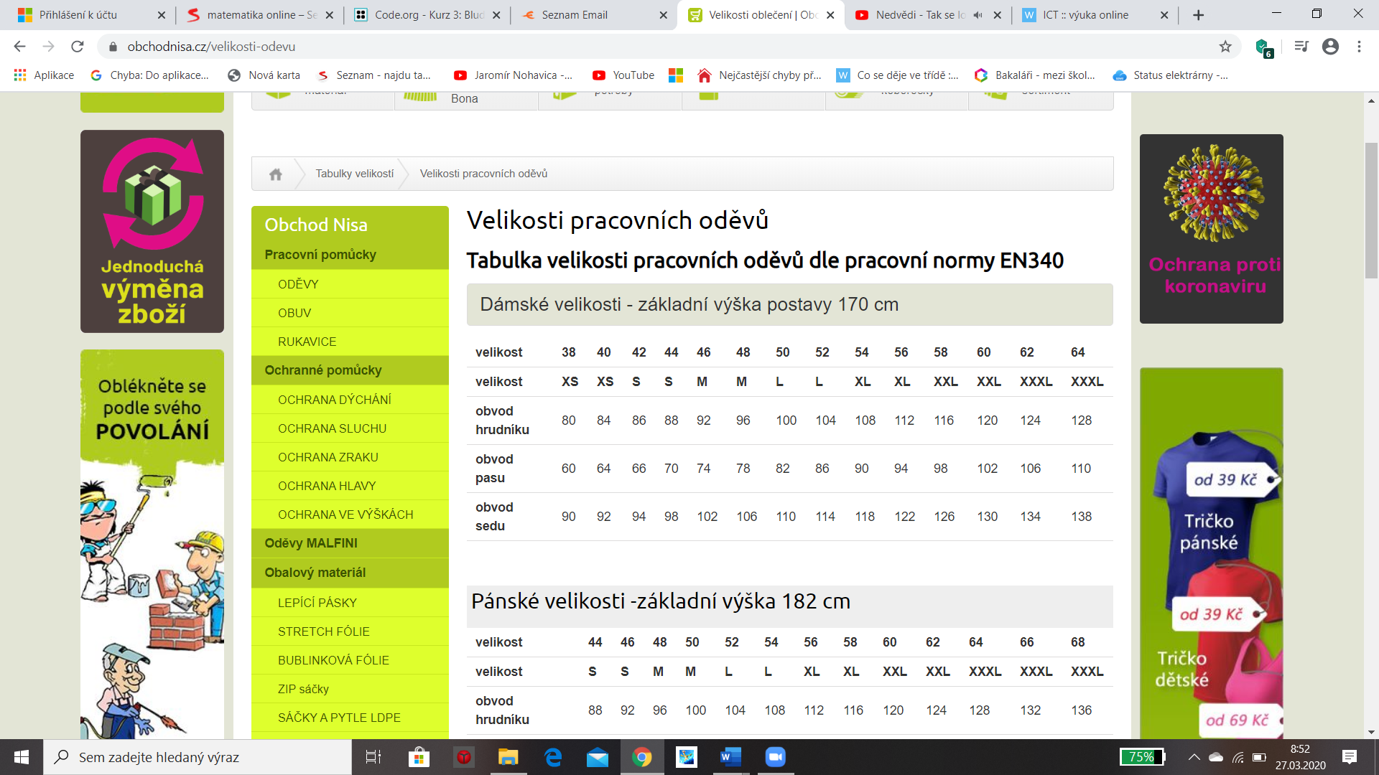

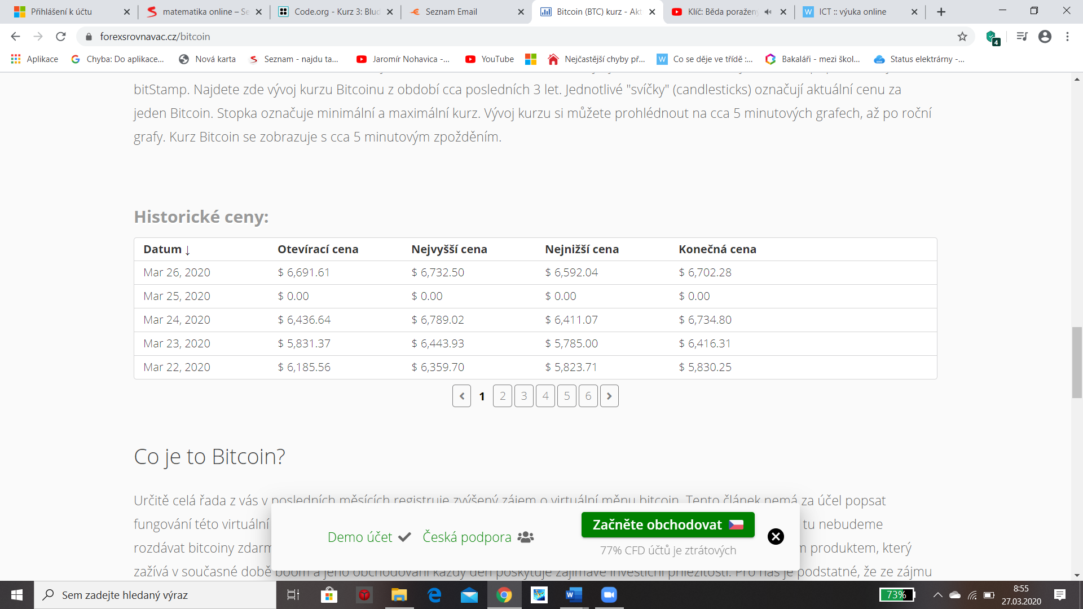

|  |  |  |  |  |  |  |  |
| --- | --- | --- | --- | --- | --- | --- | --- |
| **Výroba sedacích souprav v 2. pololetí roku 2011** | | | | | | |  |
|  |  |  |  |  |  |  |  |
| **Měsíc** | **Červenec** | **Srpen** | **Září** | **Říjen** | **Listopad** | **Prosinec** | **Součet** |
| Provoz A | 5 | 15 | 21 | 19 | 2 | 9 |  |
| Provoz B | 35 | 32 | 37 | 36 | 25 | 11 |  |
| Provoz C | 23 | 21 | 5 | 21 | 28 | 20 |  |
| Provoz D | 44 | 9 | 44 | 13 | 42 | 51 |  |
| Provoz E | 15 | 18 | 11 | 16 | 15 | 1 |  |
| **Celkem** |  |  |  |  |  |  |  |